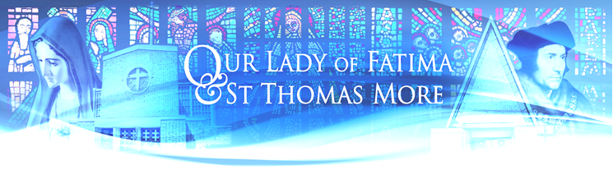

Parish Newsletter 5th Sunday of Lent Year A

Mass Intention 21st March – 29th March 2026

Our Lady of Fatima (OLF) St Thomas More (STM)

Saturday | 9.00am  6.00pm | Ireneusz&Barbara Zolcik (Gregorian 27)  Evelyn Falzon (RIP)
Sunday  Polish | 10.30am  12.15pm | May Aitken (Birthday Remembrance)  Ireneusz&Barbara Zolcik (Gregorian28) | 8.30am | Barbara & Allen Upton (RIP)
Monday | 9.00am | Ireneusz&Barbara Zolcik (Gregorian29)
Tuesday | 9.00am | Ireneusz&Barbara Zolcik (Gregorian30)  Demeter Family (Thanksgiving)
Wednesday | 7-8 pm | Adoration of The Blessed Sacrament | 10.00am | Anh Nguyen (18th Birthday)  Billy Johnson (Ann., RIP)
Thursday | 9.00am | Helen Sheils (RIP)  People of the Parish
Friday | 7.00pm | Bill Sheils (RIP) | 10.00am | Christopher Laurence (RIP)
Saturday | 9.00am  6.00pm | Samantha Lee (SI)  Michael Evans (8th year Ann., RIP)
Sunday  Polish | 10.30am  12.15pm | Nana, Oswald & Naana Donkor (SI)  Teresa Furmanek (SI – 70th Birthday) | 8.30am | People of the Parish

This 5th Sunday of Lent could well be called the "Sunday of Christian Hope". All the readings today focus our attention on the virtue of Hope that sustained the early Israelites and Christian communities through to the present day.
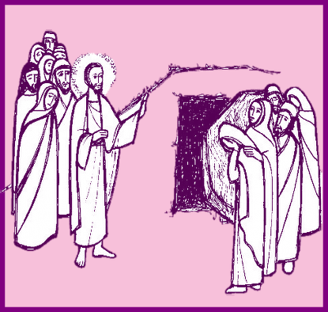
Ezechiel 37: 12-14 The Israelites are being encouraged by the promise that their long captivity would end; they would be endowed with the Lord's Spirit, and they would return to Jerusalem and they would live in and resettle their own land - the "Promised Land". It is not apparent at this stage that immortality was fully part of the religious understanding of these people. For them, "The Promised Land" was their ultimate hope.

Romans: 8-11 Following Christ's lead, however, St. Paul clearly states the doctrine of immortality with his statement that each person, through the merits of Christ, has been given the opportunity to achieve eternal union with the Source of Life from whom all have originated.

John 11: 1-45 And St. John, with his account of the rising of Lazarus, awakens in us, as it did in Martha and Mary, and absolute Faith in the person and teaching of Christ, Master of Life and Death

Missionaries of Our Lady of La Salette:
Fr Boguslaw Kot MS: Parish Priest, Fr Leszek Gamracy MS: Assistant Priest
The Presbytery, Howard Way, Harlow, Essex CM20 2NS • Tel:01279 426017
Email: harlowolf@brcdt.org

HALLS BOOKING
Our Lady of Fatima Hall olfharlow@gmail.com 07425633193
St Thomas More Hall cruzblessen@gmail.com 07399846607

SACRAMENT OF RECONCILIATION - STM: Wednesday, Friday 9.30am-10am OLF: Saturday 5pm - 5.50pm

CHURCH CLEANING: OLF Church – Friday 27th March at 5.30pm Polish Team B

FIRST HOLY COMMUNION: The children who are making their FHC at the English Mass: Practice in the church on Wednesday 25th March at 5.30am.
RCIA: The next meeting is on Tuesday 24th March at 6pm in the Presbytery
ALTAR SERVICE: The meeting is on Saturday 28th March

LENT: During Lent Friday’s Mass at Our Lady of Fatima will be at 7.00pm followed the Stations of the Cross and at St Thomas More Church will be at 10.00am followed the Stations of the Cross.
RETREAT in Preparation for the Parish Reconciliation Service
On Monday 23rd March at St Albans School at 7.00pm
FEASTS: The Annunciation of the Lord -Solemnity- Wednesday 25th March

OLF & STM Social & Fund-raising Team Please see Clara (STM) or Kay (OLF) to register your interest in joining a team for the International 5 aside men's football tournament on Sunday 7th June from 1.30pm to 4.30pm. After the main tournament, we will be holding a children's competition. Further details about the event will be available in the next few weeks.

SECOND COLLECTION this weekend and next will be for Easter flowers& Easter eggs for children.
Thank you for any contribution.
Gift Aid Donations: Please return your completed forms to Hugh, Kay or to the Presbytery. Envelopes for the new financial year will be available soon.

Pilgrimage to Knock Shrine & Co. Mayo Led by Bishop Alan Williams
15th-19th June 2026. Price of £799.00 per person Package includes Return flight from Lon Stansted – 10kg check in bag. All entertainment, excursions and guided tours representative. Single room supplement £250.00. Maximum 3. Contact: Patricia Tel: 01268 762 278 Mob: 07740 175 557 knockpilgrimages@gmail.com

Lourds Pilgrimage Fund Raising During Easter Keannan Bernardo, our young Parishioner will be volunteering with Across Paths, a charity that supports people with disabilities on pilgrimage. He will be one of nine persons helping pilgrims during their journey to Lourdes, France. The cost for each helper to take part is £1,350, which they are raising themselves. Donations are very welcome. Thank you in advance.

Pray for the sick: Josie Cronin, Keith Harris, Pam Barnard, Ivan Pirnak, J.C. Nkosa, Teresa Lamb, Noreen Wright, Grace Fisher, Kathleen Evans, Fr Bernard Grogan, Angela Walsh, Jeremy Collins, Peter Kelly, Mary Kelly, Pam Matthews, Władysław Borecki, Ewa Samborska, Peter Ryan, Adele Ryan, Nial Briody, Maria Lunnon, Fabian Andrade, Eileen Rowan, John Brickley, Helen Doherty, Philip Ketedzi, Caroline Berry, Anna Sweeney, Stanislaw Kostecki, Carmel Delaney, Donnah Dris, Conrado Shea, Ryan Tomlin, Mat Quinlan, Krystyna, Josie Cronin, Mary Quinlan, Anna Borsuk, Ruby Antony, Eileen Jolly, Anna Slota, Monica, John O’Donnell and their children, Neil, Anna Gawlik, Eileen, Kathleen Kidney, Andrew Sinclair, Pauline, Alica and Rodney Bill, Valda, sick parishioners from Ashlyn, Alexandra and Abbot Care Home.

Please pray for the repose of the souls: Maria Kunicka, Margaret Sackett, Frederick Pipkin, Gwendoline Middlecoat, Mgr David Manson, Ks. Józef Mituś, Fr Władysław Wichniarz MS, Joseph Dawood Thomas, Patricia Delahunt, Mary Patterson, May Aitken, Thomas Mulligan, Romualda Ratajczyk, Bp Thomas McMahon, Frank Taliana, Maria Cooper, Alice (Dow) Insch, Nick Cronin, Tony Poole, Mathew Joseph, Helen Noyo Owie, Br Wojciech Durlak MS, Fr Augustyn Hamielec MS, Giona Nkunim Botchway-Adjei, Christopher Keenan, Denis Grogan, Kathleen Thompson, Fr Andrzej Kuder MS, Hayley Wright, Mary Sage, Patricia Carter, Radosław Iwańczyk, Billy Lomasney, Kenneth Samuels, Terry Farrington, Kevin McGrath, Julie Bush, Janina Zdrojewska, Zbigniew Piątek, Józef Chapski, Peter Mwangi Gekonyo, Joby Joy, PJ Thomas, Eveline Falzon, Dolores Lawless, John Cywinski, Maria Cristina Galagala, Thomas Nelson, Paul Gaize, Bridget Minihane, Barbara Vernem and all those whose anniversaries occur this month.

Our sympathy and prayers to Lilianna Huggins on the death of her father and Marion Rolland on the death of her mother Jenny DeSousa. May their souls rest in peace.

stmandolfparish.co.uk.

