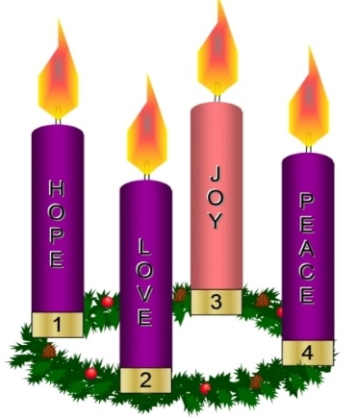
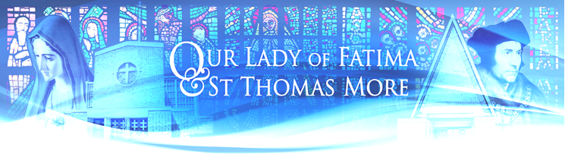

Parish Newsletter Forth Sunday of Advent-Christmas Year A 2025

Mass Intentions 20th December – 28th December

Our Lady of Fatima (OLF) St Thomas More (STM)

Saturday | 9.00am  6.00pm | Genowefa Gaweł Gregorian Mass (10)  Wendy Brand & Family (RIP)
Polish | 10.30am  12.15pm | Barbara Vernem (RIP)  Ewelina Dziedzic (Recently dead) | 8.30am | Genowefa Gaweł Gregorian Mass (11)
Monday | 9.00am | Genowefa Gaweł Gregorian Mass (12)  Florence Yao  (Thanksgiving for blessings in 2025)
Tuesday | 9.00am | Molly McLaughlin (Recently dead)  Genowefa Gaweł Gregorian Mass (13)
Christmas Eve  Polish Mass | 6.00pm  11.30pm | Hayley Wright (RIP)  People of the Parish | 10.00am  10.00pm  10.30pm | Genowefa Gaweł Gregorian Mass (14)  The Office Readings & Carols  David & Deanna Ennen (RIP)
Christmas  Polish Mass | 10.30am  12.15pm | Mary Aitken (RIP)  Genowefa Gaweł Gregorian Mass (15) | 8.30am | People of the Parish
Friday  St Stephen | 11am  Polish | Genowefa Gaweł Gregorian Mass (16) | 10.00am | Mihaela (Birthday)
Saturday | 9.00am  6.00pm | Genowefa Gaweł Gregorian Mass (17)  Paul McDonald (RIP)
Sunday  Polish | 10.30am  12.15pm | Philip & Charlotte Donkor & Family (Ann., SI)  Kasia & Krzysztof Łapińscy (SI) | 8.30am | Genowefa Gaweł Gregorian Mass (18)
The theme of expectation and new beginnings dominates today's readings. The birth of Christ means a new chance for renewal regardless of how marred and smeared one's past life story may have been.

Isaiah 7:10-14 King Ahaz is seriously depressed! He had made some bad political decisions resulting in his people becoming subjugated to the Assyrians. Isaiah disagreed with Ahaz but sought to assure him that all was not lost. God would continue to be faithful to His people. A sign would be given - Ahaz's young wife would give birth to a son as proof of God's continued presence with His people. In due course, this pledge of God's continued fidelity would find ultimate fulfilment in the birth of Christ.

Romans 1: 1-7 This pledge continues to be made known by the Apostles and all baptised people as they find in Christ the opportunity for constant renewal.

Matthew 1: 18-24 Here Matthew records for us that silent, unnoticed event which became the turning point of history.

Prayer for Lighting the Fourth Candle - Love: "Heavenly Father, as we light the fourth Advent candle of love, may your love inspire us to love one another as you have loved us. Let your love guide our actions and words. In Jesus' name, we pray. Amen."

Missionaries of Our Lady of La Salette:
Fr Boguslaw Kot MS: Parish Priest, Fr Leszek Gamracy MS: Assistant Priest
The Presbytery, Howard Way, Harlow, Essex CM20 2NS • Tel:01279 426017
Email: harlowolf@brcdt.org
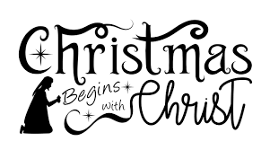
The Nativity of Christ is the discovery that we are not alone, that there is no place in this world that has not been sanctified by God’s presence, that we only need to stretch out our hands and cry, “Abba! Father!” to receive help. And this is a great miracle indeed.
The Joy is real. And so is the deep peace this message brings. What better news can we expect? The Nativity solves the root of all real problems: we no longer have to solve everything on our own.

Christmas is a perfect time to celebrate and to give thanks to those people who make a real difference in our lives. We rely on your generosity and kindness, any additional donations given at Christmas will be used to support us and our order.
Thank you for your Christmas Collection, cards, presents and good wishes. We are grateful to all who help us in any way to make this community a more loving place to be.
Wise men still seek Him. May you continue to seek the light of God's love all through the year!
Happy Christmas
Fr Bogdan and Fr Leszek

SACRAMENT OF RECONCILIATION
Advent Reconciliation Service: Sunday 21st December at 5pm in Our Lady Fatima Church.

CHURCH CLEANING: OLF Church – Monday 22nd December at 11.00am – Team A and all Volunteers
STM Church - Saturday 20th December at 10.00am (Volunteers)

FIRST HOLY COMMUNION
First Holy Communion meetings will continue for children on Wednesday 7th January 2026 at 5.30pm in the church.

RCIA: The Catholic Church's process for adults to be introduced to the Catholic faith, learn its teachings, and become full members by receiving sacraments like Baptism, Confirmation, and Eucharist. The next meeting is on Tuesday 13th January at 6pm in the Presbytery.

SOCIAL EVENT: STM are hosting a breakfast after mass on Sunday 28th December. Please bring and share items or just bring what you would like to eat. Everyone is welcome.

COUNSELLING Service for OLF & STM
The service is free to parishioners. Clients are requested to donate £15 for each session towards the church. Further details and business cards are available in the porch or from Fr Bogdan or Dr Ray Aldridge-Morris on 07946 854632.

HALLS BOOKING
Our Lady of Fatima Hall olfharlow@gmail.com 07425633193
St Thomas More Hall cruzblessen@gmail.com 07399846607

Pray for the sick: Stephen Galagala, Keith Harris, Pam Barnard, Ivan Pirnak, J.C. Nkosa, Teresa Lamb, Noreen Wright, Romualda Ratajczyk, Grace Fisher, Kathleen Evans, Fr Bernard Grogan, Angela Walsh, Jeremy Collins, Peter Kelly, Mary Kelly, Pam Matthews, Władysław Borecki, Ewa Samborska, Peter Ryan, Adele Ryan, Nial Briody, Maria Lunnon, Fabian Andrade, Eileen Rowan, John Brickley, Helen Doherty, Philip Ketedzi, Caroline Berry, Anna Sweeney, Stanislaw Kostecki, Carmel Delaney, Donnah Dris, Conrado Shea, Ryan Tomlin, Mat Quinlan, Krystyna, Josie Cronin, Mary Quinlan, Anna Borsuk, Ruby Antony, Eileen Jolly, Anna Slota, Monica, John O’Donnell and their children, Neil, Anna Gawlik, Eileen, Kathleen Kidney, Andrew Sinclair, Pauline, Alica and Rodney Bill, Valda, sick parishioners from Ashlyn, Alexandra and Abbot Care Home.

Please pray for the repose of the soul of: Patricia Delahunt, Mary Patterson, Fr Władysław Wichniarz MS, Bishop Thomas McMahon, Thomas Mulligan, May Aitken, Frank Taliana, Maria Cooper, Alice (Dow) Insch, Nick Cronin, Tony Poole, Mathew Joseph, Helen Noyo Owie, Br Wojciech Durlak MS, Fr Augustyn Hamielec MS, Giona Nkunim Botchway-Adjei, Christopher Keenan, Denis Grogan, Kathleen Thompson, Fr Andrzej Kuder MS, Fr Z. Pałys MS, Hayley Wright, Mary Sage, Patricia Carter, Radosław Iwańczyk, Billy Lomasney, Kenneth Samuels, Terry Farrington, Kevin McGrath, Julie Bush, Janina Zdrojewska, Zbigniew Piątek, Józef Chapski, Peter Mwangi Gekonyo, Joby Joy, PJ Thomas, Eveline Falzon, Dolores Lawless, John Cywinski, Maria Cristina Galagala, Thomas Nelson, Paul Gaize, Bridget Minihane, Barbara Vernem, Romie Quinn, and all those whose anniversaries occur this month.

Condolences Our deepest sympathy to the family of Mary Patterson who recently died.
The funeral will be held on 7th December at 11am in Our Lady of Fatima Church.

stmandolfparish.co.uk

